**Auto formation : le marketing digital**

[**https://www.youtube.com/watch?v=T4JnZ6lCfog&list=PLvaIgvOmhah9HhrjC\_-WIQuJgLdDyPyuk&index=2**](https://www.youtube.com/watch?v=T4JnZ6lCfog&list=PLvaIgvOmhah9HhrjC_-WIQuJgLdDyPyuk&index=2)[**https://www.youtube.com/watch?v=nU-IIXBWlS4**](https://www.youtube.com/watch?v=nU-IIXBWlS4)

[**https://www.youtube.com/watch?v=ybrfp4ayQOE**](https://www.youtube.com/watch?v=ybrfp4ayQOE)

**formation open class room :**

Digital : tout ce qui se rapporte au doigts et facilite la rencontre entre l’offre et la demande. Si le marketing passe par des écrans, c’est déjà du marketing digital.

Le web marketing est en fait différent du marketing digital. C’est donc un sous domaine du marketing digital. Ensuite, il y a les différentes spécialisations :

* Publicité en ligne
* Community management
* Référencement
* Emailing

Le marketing digital permet de toucher plus de monde plus efficacement.

Quelle est la différence entre le marketing traditionnel et le marketing digital ?

Pour le marketing traditionnel, il s’agit de supports peu interactifs tel que les journaux et ou les affiches, la radio, le téléphone, …. De plus, le ciblage est vague et donc indifférencié.

Dans le digital, la connexion permet de mesurer la performance des actions de marketing digital ( le bouton stat sur facebook par ex). Les actions du marketing digital sont quant à elles précises et ciblées.

Il y a également des différences en termes de relation client et de planification. Dans le traditionnel la planification est lente et irréversible alors que pour le digital c’est instantané et agile. En termes de relation client, pour le traditionnel, c’est unidirectionnel, il n’y a pas vraiment de retour alors qu’en marketing digital il y a un « échange » avec le client, c’est multidirectionnelle : il y a un marketing sortant visant à pousser l’offre vers le consommateur, et un marketing entrant qui demande la permission du client.   
  
Même si le marketing sortant à mauvaise presse, il n’a en soit rien de mauvais.

**a) qu’est ce qu’un plan marketing**

L’intérêt du plan marketing c’est de faire plus de bonnes choses. Sachez cependant que trop d’analyse paralyse …. Souvent ça se décompose en quatre phases : définir les objectifs, étudier le marché, établir la stratégie marketing et enfin le plan d’action. Il s’agit d’un système flexible qui peut s’adapter en fonction de la taille de l’entreprise. Ce plan peut se dessiner en texte ou en tableur.

Un marketeur sans plan peut faire des détour inutile, faire des erreurs stratégiques, payer trop chère, …

Case study : « mimine » il s’agit d’une entreprise bordelaise produisant des vêtements pour enfants cousus à la main et étant évolutifs.

**b) définition des objectifs**

Quel est l’objectif final ? il faut en permanence le prendre en compte … Il faut savoir qu’une entreprise à plusieurs raisons d’être, la principale étant sa mission, sa vision à long terme. C’est très important car elle conditionne les objectifs stratégiques (la vision de moyen terme) qui eux-mêmes vont structurer les objectifs opérationnels ( qui sont les résultats attendus à court terme). Ces objectifs doivent absolument être mesurables.

Mission d’une organisation : raison d’être. Par exemple pour Open class room c’est rendre l’éducation accessible.

Pour mimine c’est habiller les enfants du plu jeune au plus vieux sans gaspillage.

Pour mimine : un exemple d’objectif stratégique pourrait être de développer la vente en ligne pour capturer au moins 10% des parts du marchés français des vêtements évolutifs pour enfant d’ici 2018. Pour les objectifs opérationnels il faut un plan d’action pour associer à chaque action à une opération. Les objectifs opérationnels : la notoriété (séduire le plus de gens possibles ) , l’acquisition ( avoir un max de client et en max de ROI ) et la fidélisation ( capitaliser sur les clients existants)

Pour mimine : un ex de NOTORIETE pourrait être de faire connaitre sa marque à plus de 30.000 personnes, 4 fois par personne, sur le mois de Janvier.

Un ex d’ACQUISITION : acquérir 300 nouveaux clients en 1 mois avec 3000€ de budget.

Un ex de FIDELISATION : réactiver 5 % du fichier client sur le moi de mai.

La méthodologie **SMART**: 5 facteurs a prendre en compte pour définir un objectif, celui-ci doit être :

Spécifique, mesurable, actionnable, réaliste et temporel.

Pour voir si il est réaliste, il faut faire une

**Une étude de marché :**

Marché = point de rencontre entre l’offre et la demande, il faut connaitre celui-ci pour éta²blir une stratégie qui y serait adaptée.

Attention : sélectionner les informations qui nous arrange le plus, il faut trouver une source de confiance. Faire ce type d’étude demande une méthodologie très particulière. L’étude dépendra de la taille et des ressources de l’organisation.

Pour faire l’étude, on peut faire appel à une entreprise, conduire l’étude sois même ou bien chercher les résultats d’une étude existante. Il peut y avoir plusieurs types d’informations concernant un marché : dynamisme, saturation, …

Quelle analyse faire des résultats ? quelle conséquence ?

Par exemple, pour mimine, elle doit se concentrer sur un marché de niche, sur son segment particulier, qu’elle fait « mieux que tout le monde ». Pour ceci par contre, il faudra une estimation.

Marché global vêtement pour enfant = 4 milliards

Marché global vêtement enfant évolutif = 4 millions par exemple

Marché de vêtement enfant évolutif sur le net = 2 million

* Ok pour mimine

Il y a ensuite deux types de ciblages :

a) BtoC

b) BtoB

Dans le cas de mimine, ce sont les parents qu’on va cibler. Donc : qui est le client type ( persona) de Mimine ?

Par ex on peut déterminer des **critères sociaux démographiques** : genre, âge, géographie, famille, budget, revenus, études

En suite : des **critères comportementaux :** sexe, enfants, écologie, bien être, ….

Deux types de concurrence :

1) indirect : offre différente mais la consommation canibalise les ventes

2) direct : produits ou services identiques aux nôtres.

Être seul sur un marché n’est en fait pas très rassurant mais il faut se poser la question : est ce qu’il y a assez de place dans le marché pour x nombre de concurrents ?

**La stratégie marketing**

Une bonne stratégie capitalise sur les forces, permet de saisir des opportunités et évite les faiblesses et les menaces. Cette stratégie est le SWOT : strenghts, weaknesses, opportunities and threats.

Pour Mimine :

Strenghts : qualité artisanale ( cousus mains )

Weaknesses : volume de production et faible marge

Opportunities : place pour de l’offre plus haut de gamme, marketing idée cadeau, impact santé et environement

Threats : géants du prêts à porter, concurent direct, ….

Il faut voir le cadre SWOT comme quelque chose d’ouvert, il faut faire des liens entre les divers éléments.

Mimine et sa stratégie de distribution : Elle pourrait par exemple TESTER LA DEMANDE grâce à des plateformes comme Kiss Kiss Bank ou kick starter. Elle peut ensuite utiliser une plateforme e-commerce en ligne puis créer sa propre boutique en ligne.

**Le plan d’action**

Ligne directrice globale transformé en opérations spécifiques. En fait, ce qu’il y a de très avantageux avec le marketing digital, c’est qu’il est possible d’aller assez loin avec des actions « gratuites ».

Le rétroplaning donne en fait une vue d’ensemble des actions sur toute l’année. Certaines actions sont récurrentes et d’autres plus ponctuelles. Grâce au planning on peut aussi définir la fréquence de certaines actions. Ça permet aussi de voir comment se manifestent certaines tendances.

**Comment améliorer la performance des actions ?**

Le cycle de vie du client et la méthodologie AIDA, il faut pouvoir porter un regard critique car certaines actions vont fonctionner et d’autres pas. Il faut savoir combiner les bons éléments du marketing mix et du plan d’action.

Le tunnel de conversion représente le parcours utilisateur quand il traverse notre système marketing. Il faut voir ou l’entonnoir s’amincit le plus pour réagir a ses faiblesses.

Le client a aussi un cycle de vie, au début ce n’est qu’une cible, à ce stade elle ne connait même pas notre existence donc il faut susciter son intérêt pour qu’il devienne un visiteur qui sera intéressé par ce qu’on fait. Pour le transformer en prospect, il faut stimuler son désir. En suite il faudra faciliter le passage à l’action pour transformer le prospect en client. Idéalement, il faut pouvoir transformer les clients en ambassadeurs qui iront recommander la marque à d’autres clients potentiels.

Après, il faut adapter la communication en fonction des attentes et de la cible : personnaliser le message et la communication.

Pour structurer sa communication : AIDAR :

Il faut attirer l’attention

Susciter l’intérêt

Susciter le désire

Faciliter le passage à l’action

Faciliter la recommandation

Ensuite, il faut savoir que l’efficacité marketing dépend principalement des relations humaines, les techniques ne seront que des canaux servant à faire passer le message à quelqu’un. A la fin, les gens seront touchés un par un.   
  
La première étape c’est **attirer l’attention de la personne**, a savoir qu’on sera pas le seul annonceur à le faire, il y a une compétition pour attirer l’attention. Il faut donc s’informer à propos du neuro marketing : c’est une question de sens : en digital, on utilisera surtout la vue et l’ouie. Les choses étranges et excentriques attires plus l’attention, de même que les couleurs vives , la nourriture, les humains en bas âge.

Ecrire pour le marketing c’est unique car il faut écrire synthétique, précise, direct et personnel. En fait, s’adresser à tout le monde, c’est ne s’adresser à personnes. Petit truc : aller checker les vidéos qui attirent le plus de monde sur youtube. Est-ce que la nouveauté attire l’attention ? Par exemple, le bad buzz est une technique pour attirer l’attention.

Si l’on n’est pas une célébrité, il faut plutôt soigner son image et sa réputation. Il faut attirer l’attention et susciter l’intérêt.

Comment savoir si le ciblage est trop large ? c’est le taux de clique sur les bannières qui montrera le taux d’intérêt des gens, ici ça sera le KPI. Pour faire une offre qui raisonne avec la cible : le cerveau fait en constance des recherches d’opportunités et de menaces.

Ce qui est intéressant pour capturer un visiteur c’est lui proposer de résoudre un problème à son arrivée sur le site.   
  
Comment **transformer les visiteurs en prospect ? :**  Il faut stimuler le désir du visiteur pour qu’il comprenne son besoin et en quoi le produit proposé résout ce besoin. Attention à la « landing page » la page d’accueil sur laquelle le visiteur arrive en premier lieu sur le site. Il faut optimiser la page pour convertir au mieux les visiteurs en prospects. Il faut être synthétique et concis. Pour stimuler le désir, il faut expliquer au visiteur le problème qu’on cherche à résoudre donc il faut choisir les mots avec précisions et avec empathie, il faut que le visiteur puisse s’y identifier. Pour désirer quelque chose il faut pouvoir le visualiser et se le représenter. Les images doivent appuyer ce que dit le texte.

Le visiteur doit s’imaginer le produit une fois celui-ci dans ses mains. Il faut un visuel représentatif, il faut également avoir des vidéos. Une vidéo marketing est une démonstration du produit, le client pourra donc plus facilement le visualiser.   
  
Comment savoir qu’un visiteur devient un prospect ? Le visiteur fait ou ne fait pas des actions sur le site qui sont des traces pour savoir ou se trouve le visiteur en question (en terme de processus d’achat )

Taux de rebond : si le visiteur rebondit, il quitte directement le site, c’est probablement car la landing page n’est pas assez accrocheuse. Il faut donc une harmonie entre les messages qui attirent le visiteur et ceux qu’on retrouve sur le site.

Un taux de rebond supérieur à 80% est vraiment catastrophique. Entre 60 et 80 % c’est plutôt mauvais, entre 40 et 60 % c’est moyen et un entre 20 et 40 % c’est plutôt bon, inférieur à 20% c’est fantastique.

Autre indicateur : prise de contact, mise en panier, mise en favorise, clique sur une page produit, ….

Ces actions permettent de calculer un taux de convertion/transformation. On peut le calculer pour beaucoup de chose ici le taux de conv des visiteurs en prospect.

Formule : ( total prospect / nombre total vivisteur ) \* 100

Mimine : 16.000 prospects et 80 000 visiteurs = 20 % donc plutôt bon

**Comment convertir les prospects en clients ?**

Il faut assister le prospect dans sa prise de décision pour l’orienter vers nos services. Il faut convaincre le prospect ou le persuader.

Convaincre fait appel à la raison à des arguments rationnels et explicites

Persuader c’est faire appel aux sentiments avec des arguments affectifs et implicites.

Dans les deux cas il faut anticiper questions et objections du prospect. Ce qui est intéressant ici c’est d’avoir un bon support client : il faut s’assurer que la mise a dispo d’un service client sera rentable. Cela dit, faire changer d’avis quelqu’un est plus chère que d’attirer quelqu’un de nouveau.

Le parcours utilisateur doit être le plus simple possible : réduire toutes frictions, c’est-à-dire les efforts à fournir par le prospect pour trouver son chemin : pour se faire il faut des boutons d’appels à l’action indiquant clairement l’action suivante à faire.   
  
Pour mettre ces balises en évidence, il faut joueur sur l’effet de contraste. Par exemple, remplir un formulaire est considéré comme demandant beaucoup d’efforts, attention à la « flemme » de l’utilisateur.

Pour conclure plus vite : la gratuité, les offres promotionnelles ( limitées dans le temps) pour créer un sentiment d’urgence, pour inspirer la confiance on peut mettre en évidence des témoignages : plus l’autorité des témoins est forte, plus elle attire la confiance. En marketing digital on est « data driven ».   
  
Donc comment mesurer la conversion des prospects en clients ?

Formule : (nombre de clients / nombre de prospects ) \* 100 = taux de conversion clients

Taux de transformation globale : nombre de clients / nombre de visiteurs \*100 = taux de conversion globale.

Les premiers choix marketing sont rarement les bons, c’est à force de tester de façon itératives qu’on trouvera la bonne solution,  il s’agit de l’AB testing : donc modifier quelques éléments et puis suivre l’évolution avec les KPI’s. AB Testing : AB testy, optimisely, …. Exercice : identifier les techniques sur leur site. Un site doit convertir au mieux les visiteurs en prospects et les prospects en clients.

**Comment fidéliser les clients et en faire des ambassadeurs ?**

Acquérir un client n’est pas vraiment l’objectif final. Quand on a un client, il faut avoir un nouveau type de relation avec celui-ci en le satisfaisant. Moins chère de faire revenir un client satisfait que d’en faire venir un nouveau. Par contre faire revenir un client insatisfait coute plus chère que d’en trouver un nouveau.

La satisfaction c’est l’expérience vécue par le client soustraits des attentes que le client avait. Donc si l’expérience est excellente et les attentes moyennes, ben la satisfaction sera assez bonne.   
Il ne faut donc pas survendre le produit ni le sous vendre.

Il faut créer des attentes fidèles, après et pendant la vente, il faut en faire un « tout petit peu plus » pour satisfaire et rendre heureux le client. Le minimum à faire c’est demander un feed back au client, pour collecter ces feedback et évaluer la satisfaction :

**CSAT :** customer satisfaction score : données simples d’exploitation. Il faut donner l’opportunité de dire ce qui a provoqué l’insatisfaction. Très utile pour la satis à un moment PRECIS

**NPS :** net promoter score : « dans quelle mesure vous recommanderiez le produit à vos amis ? » Meilleur pour calculer l’engouement plus « global ».

Pour passer de client à ambassadeur : boutons de partage et codes de parrainage. La valeur à vie d’un client : sommes des transactions qu’on a eue avec le client. Permet de calculer le cout d’acquisition maximale.

Formule : (valeur moyenne d’une commande pour ce clien \* nombre de commandes du client ) – le cout d’acquisition moyen.

On peut donc augmenter la valeur d’une commande, augmenter le nombre de commandes ou baisser les couts d’acquisition.

**Why digital marketing is important :**

<https://www.youtube.com/watch?v=nU-IIXBWlS4>

First, a lot is happening in 60 sec on the internet : 2.1 milions snaps, 41.4 milions facebook msgs, …. After, there are several differences such as the lack of real time result for traditional marketing while for the digital marketing you can have instant real time results and it is also cos efficient. Also, digital marketing is versatile and has a much wider scope than traditional marketing.

In a nutshell, digital marketing is the act of promoting products or services with the help of digital devices or technology.

What are the types of digital marketing ?

1) SEO

2)SEM : search engine marketing : google ads, …

3) E mail marketing

4) affiliate marketing : based on commissions from third parties

5) social media marketing

6) content marketing : different types, videos, assets, infographics, ….

7) mobile marketing : a strategy on its own  
  
There are lots of way to promote the product

**Customer lifecycle**

There are different stages :

1) awareness stage :

What is the product we are selling, why does a customer need the product and what solutions does the product provide ?

Help potential customers discover the brand with the help of content marketing such as SEO SEM and SMM. The high priority is content SEO SEM SMM affiliate. Medium priority would be email and mobile and low priority would be to display ads. You must create a high quality content that people are searching for. SEM increase your sites visibility on search engines and websites through paid advertising in order to drive traffic and gain brand awareness. SEO optimize your website to rank higher on search engine results pages in order to drive traffic and generate leads. After, SMM promote the product and the content on social media channels in order to drive traffic and generate leads for the organisation. Affiliate : traffics sources : paid, unpaid, social media, referal, email, direct traffic, …

2) consideration stage :

What features make the product valuable to others and how will i increase customer engaement towards my product ?   
  
In this stage, customer considers the product so help them understand how the product is valuable to them. Here, there would be high priority for email, mobile, display and ads. The medium priority would be for content, SEM , SEO and SMM. The low priority would be for the affiliate part.

In this stage plan the campaigns around welcome emails, newsletter, product descriptions, ratings and reviews of the product, …. You must encourage customers to buy the product by : creating detailed blog articles about the product, opting for a customer testimonial and guest blogging.

3 Purchase stage

How are my prices compared to my competitors ? Is my brand more credible than others ? That can be stars on google mybusiness, make sur people are reviewing you. Respond to all reviews : it shows than you are willing to take criticisms to better implement your product.

In the purchase stage : email , mobile, SMM , display and adds are high priority while content SEM and SEO are medium priority. Low priority would be for Affiliate. After Econsultancy, 83% of the online visitors must be pushed to actualy make a purchase. At this stage a prospect must be given an offer and assistance to make a purchase.

4) post purchase stage

What additional product could the customer buy ?

How to improve the customer buying experience ?

Will the customer refer us to others and if so why ?

Nurture your relationship with customers to ensure they remain loyal to your brand. Here, high priority is for email, mobile, SMM, content, display and adds. Medium priority is for SEM and SEO and low priority for Affiliate. A poll can be posted on facebook, … purpose is to get some feedbacks. This can be done through follow up emails and customer care contents for instance. Give rewards for customer feedback, give exclusive discounts to active customer or give referral opportunities to your customers. Use banner ads, give customer advices, use the plateform to enhance what is being purchased by the customer.

For instance, if a customer has bought a pair of sports shoeds, recomend him her to purchase sport shoeds, shorts, water bottles and other accessories with exclusive discounts.

**What is digital marketing ?**

It is very broad : search engines, websites, social media, mail, mobile applications, … There a lots of places to apply digital marketing.

**How is digital marketing useful ?**

Provides differents metrics to help determine how well your campaign is going, allows you to provide personalized user experiences, allows ad campaigns to be visible across the world. A global audience can be reached very easy at a very low cost.

Digital marketing also provides a cost-effective alternative to traditional marketing methods. Moreover, small investments can provide substantial return on investments and it also enables to target users bases on their actions and preferences. For instance a cost per click at 0.10€ for a product sold at 10 € can lead to a very high ROI.

Furthermore, digital marketing helps build brand awareness and reputation of the business and also provides a plateform for the marketer to be interactive with the audience helping the marketer staying relevant and competitive.

**What are the types of digital marketing channel ?**

1)SEO :

a) first form : on page SEO : everything to do with a website

b) second form : Off page SEO : every thing to do with a website but not on the website.

Make sure the domain is relevant in the eyes of Google.

What would be relevant here is those factors : header tag, image alt text, featured snippet, page speed, internal speed, title tag, site search, is there a lot of content ?

The title tag should be unique and include certain type of keywords

Off page SEO : involves using promotion methods for enabling your website to improve its organic ranking. It is a method of navigation links from other websites to your own. Also for building external links to help gaining organic search ranking. There are two types of link building : the follow button and the dont follow button.

Nofollow vs dofollow links, whats the difference ?

<a href=  <https://backlinko.com/blog> >

<a href = <https://backlinko.com/blog> rel = « nofollow » >

Search engine ignore the links whith attribute no follow.

Do follow links allow search engine crawlers to follow the link for a good boost over SERP and pass the link juice ( reputation) to the destination domain.

Popular tools used for SEO : Google keyword planner, ahrefs, Mozz, semrush, pingdom.

Google keyword planner is to find keywords … thanks captain OBVIOUS !!. For that you need a google add account and then go on the section google keyword planner. It is giving extensive and enlightning results about keywords :   
  
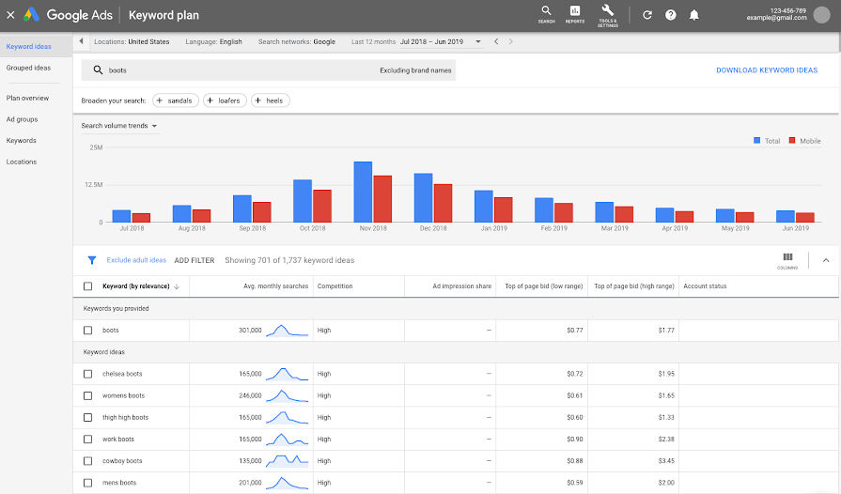

Some keywords are very competitive and others are realy not. You should play with the google tool to check which keyword would be the most relevant for your business. Ahrefs can show you how many domains are pointing towards your website. The tool pingdom gives lots of information about the « health » of the website.

Google analytics gives you informations such as the site speed, speed suggestions. Google analytics gives you some suggestions : page speed insights for instance which will gives you some feedback on how the page is performing.

Mozz has a lot more informations such as the site crawls, page optimization, what can be done to improve the SEO performance.

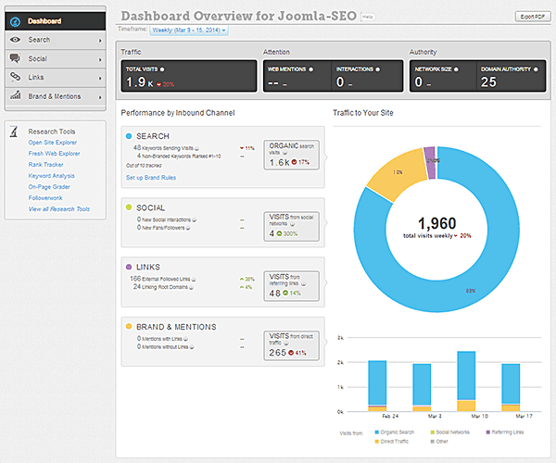

Lots of different off page seo tools available.

2) content marketing

Blogs, videos, infographics, case studies, white papers, ebooks, …. It is a form of marketing to stimulate interest in a brand’s product or service by creating and sharing online material. Decide what goal you want to achieve with your content marketing capaign and then define buyer personans to determine the audience best suited for your content and finaly run content audits to determine the best type of content that can be used.

After you have to choose an appropriate content management system ( wordpress, website ? ) then start brainstorm for ideas for new content then settle on a particular type of content you wanna create and finaly publishing and managing your content.

**Tools available for content marketing :** buffer, BuzzSumo, followerwonk, hootsuite, ….

Wordpress can be optimized for SEO easily. The content must be chosen according to the audience. The audience must be introduced to a particular product. Videos are versatile and powerfull to send a message.

3) social media marketing

It is a form of marketing that involves creating content for different social media platforms to increase website traffic, user engagement, brand awareness and to achieve other marketing goals, this involves sharing content like : user generated content, interactive content, infographics, content with images, videos, contests, ….

Process : set up goals that you want to achieve with your SMM campaign. Then you want to understand what content would be best suited for your targeted audience. You then also wanna research about your competitors and find out what works for them. Finaly conduct a socdial media audit.

Next step would be to set up accounts in social channels and define a strategy to be used in each of them. After, you can take inspiration from case studies and other famous brands. After, you have to create a social media content calendar. Finally you can test, evaluate and adjust your strategy. The calendar is there to optimize the SMM strategy. There are lots of differents forms of content that you can use on social media : videos, infographics, just an image, …

For SMM lots of tool available : post planner, buffer, hootsuite, sprinklr, …. In sprout social you wanna be able to organize your assets and from this calendar you can post and organise according to what has been planed on the calendar. You can then check whats engaging and whats not engaging. In some cases you can actualy pay to have your posts out there. For that you want to create an account on Facebook ads manager : first you have to choose an objective then you have to choose your audience, then specific placement with specified budget. You can do lots of specific targeting.

For further informations : check the video « how to start social media marketing ».

4 search engine marketing :

It is an advertising model that can be used to direct traffic towards your website by paying a fee each time someone clickls on your advertisement. These advertisements include text ads, image ads, video ads, etc. Some of the channels that can be used for SEM are : google ads, bing ads, AdRoll, … There are also twitter, …

First you have to determine the goals you wanna achieve with your campaign, then you have to choose a list or relevant keywords best suited for your brand but also finalize your keywords and bid on relevant keywords finaly set up an attractive headline for your ad campaigns. After, you can monitor how well your campaigns are doing and measures the results. You wanna be able to measure your campaign by monitoring how well your campaigns are doing and measure the results, and then optimize your campaign and retarget potential customers.

A good ad dis using everything available to it. You wanna be able to take advantage of what google is giving you. Running a carousel for instance, .. With google you have the « new text add » tool which is usefull. An add must be healthy and have as much informations as possible.

5 Affiliate marketing

Its a form of digital marketing involving the fact to pay commissions to a website or other entities for adverstising the merchants product using referrals. Affiliate are incentivized on the basis of : registrations, emain sign ups, conversions and subscriptions. How much are you going to incentivize ? The process : use a tool or a platform to find affiliates to advertise your product, after set up rules, guidelines, image specifications, commission costs, etc … Affiliates apply to advertise on your behalf. Select an affiliate thats best suited for your brand. Then customers click on ads or links which send the user to the merchants website. Once a customer make a purchase, the affiliate network makes a record of it and then the transaction is validated and credited to the affiliate, finaly there is the paid commission.

Amazon associates is an exemple of affiliate marketing. Other tools would be : affiliate conversant, AWIN, tradedoubler, maxbounty, ….

6 native advertising

Advertisements that are featured on a platform alongside content that is not paid for. Logically, ads are placed with sens : for instance : an add about HBO on buzzFeed. Ads must be placed next to content that is naturaly relevant.

7) email marketing

Use to personalize email to convert prospective user sinto customers

Identify target audience and create segments then create campaigns and set an appropriate call to action ( CTA). Then choose an appropriate email marketing tool such as mail chimp or hubSpot or marketa. After you have to test your email before sending them to do so use email marketing tools to send campaigns immediately or schedule them. Then craft an attractive subject line and copy. Set up a suitable design for your email. Perform tests for your different ideas and analyze performance ( open rate, CTR, response and rate and optimize campaigns ). Other tools are sendInBlue and Marketo. mailChimp is a really cool tool.

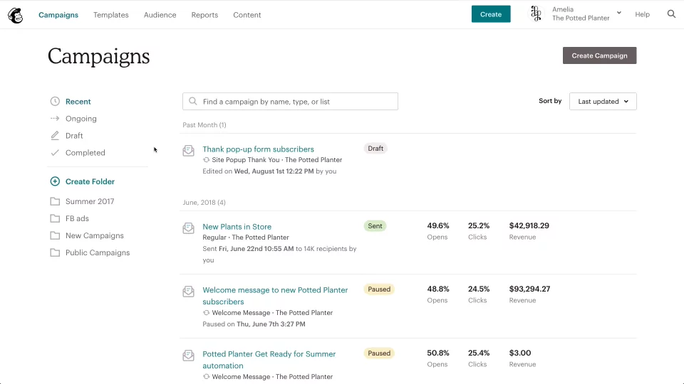

Location that opens the email, top link clicked within those emails. There are also templates to send mass emails.

8 online PR

It involves obtaining online coverage with digital publications , blogs and other content based web sites !. It works like PR in traditional marketing but for the online space. Channels that can be used to maximize the efforts are :

Connecting with reporters on social media to develop a relationship with them

Use engaging user reviews to help humanize the brand

Responding to comments helps generate productive conversation

Basically there are PR firms wich are doing that as a living. The website PR.com can help you do it by yourself. You can even submit press releases. There are other tools : PR news wire.com. There are agregation sites such as Feedly, Panda, Metacritic, esciencenews, the morning news, popUrls, ….

**Digital marketing Tools**

1)SEO : sem rush, bref, google

2)Paid : ADroll, facebook,

3)Email : mail chimp, sendInBlue

4)Web analytics : google and youtube

5)Affiliate : ClickInc

6)Social media : hootSuite, buffer, sproutsocial

7)Competitor spying : BuzzSume, SpyFu,

1) Google search console, sem rush, google keyword planner, Freemium moz, ScreamingFrog, ahrefs,

These tools allow to search for a list of relevant keywords. In google keyword planner, try out your keywords to see which one of them are relevant. How many search querries i can expect from this or that keyword, …. On the other hand, you could also use the Moz keyword explorer which is a good alternative and free tool.

-Search for a list of relevant keywords

-Choose keywords with high search volume and low difficulty

-Select primary and secondary keywords wisely

-Identify the keywords that your competitors are ranking for

-Search engine bots to crawl and index your website more effectively

-Check the correct format of the sitemap structure

-Monitor website backlinks

-Analyze the strongest links of your webpage

-Perform competitor analysis

What google does is letting us know issues that gives the website a bad search ranking. What google sees when they crawl our site ?

You could also add a new sitemap. After, there are the top linked pages and the top linking sites that points to your website.

After what about the performance report ? First, it can be linked with google ads. Queries typed in google are there giving us informations according to number of clicks etc for instance

The tools of google allow you to

-Measure ratio of refering domains to backlinks

-identify and disavow poor backlinks

-track number of dofollow and nofollow links

-track your website page ranking

-measure average click-through rates and impressions

-track keyword ranking for desktop and mobile across locations

-identify top performing, gaining and losing keywords.

Mozz is usefull when it comes to off page optimization. Also for how « spanny » a website is, with indicators such as domain autorithy, …

3) email marketing tool

Among the freemiums you fin the two that we have already discussed about : mailChimp, hubSpot, marketo, sendInBlue and convertKit. Those tools allow you to :

-send bulk emails to the target audience

-create campaigns, segment contacts and send content designed for specific segments

-send transactional emails, create workflows and segment users

- acess email templates n list mangement and email tracking with detailed insights

-create smart automated campaigns

-set up email delivery based on the user time of the day

- automatically segment contacts based on geolocation

-perform multi variate testing

-analyze performance and optimize campaigns

-trigger automatic responses bases on user action

3)Mail chimp

Template campaigns or set your own up. There are lots of template for the layouts, you can also choose the themes, the saved templates, campaigns or you can code your own. There is thus lots of flexibility.

You can also view reports on your campaigns such as list average for this or this campaign, …. Check also the social performance, the place where there are the most clicks, ….

Moreover, you can link mailChimp to analytics and you can also manage your audience list.

Furthermore, there is the possibility to use the Campaign URL builder tool, which is used with google analytics demon and tools. Here, you can track different campaigns.

4)Campaign url builder

Basically, it is a campaign tracker under the section demo and tools de google analytics. You can improve your campaigns by referencing campaign source, campaign medium, name, content, … Those are called the utm parameters. After if you go to acquisitions, campaigns, all campaigns, you can make further researches on your campaign. To sum up it is the email performances.

5)Web analytics tools

You have the choice for the freemiums which are available : there is first google analytics then adobe analytics, kissmetrics, spring metrics and youtube analytics. You wanna be able to identify the location of your website visitors by using their IP adress. You might also wanna track engagements metrics such as the bounce rate, the average session duration , the pages per visit, ….. After you can determine the ration of new visitors to the visitors returning to your website.

Then track organic traffic on a monthly basis with the users per session. You might also like to verify UTM link tracking. Also track your goals ( like website conversions) and optimize your sites and channels performance.

Audience in google analytics tells us who comes to our website. The visitor uses this language on this device from this or that country, …. Good picture of whos coming thus. You also have to know that more and more people are starting their day on their mobile so you must take that into account by making EVERYTHING ( website, …) responsive.

Concerning acquisition reporting : how the traffic got to the website. You can see referal, emails, socials, different marketing channels. You can also check the different sources of media. All performance metrics are in the google search console.

In the behaviour part you have the response : where do the search content goes, what page how many times itw as viewed, how is the traffic behaving in the website, landing pages tells us the behaviour of a visitor when he landed on the website soi t is is highly relevant.

Page load time is taken very very very seriously so pay attention to that. There are opportunities and diagnostics which tells you what can be done to improve the loading speed and the geneal quality ( such as removing useless CSS ).

Then you have categorie top events to have the statistics about the video in a very precise manner.

You can **set up events for your website with the platform Google tag manager.** Youll be able to see how many people did come to the websites and how they behaved regarding the deffirents events.

If you measure how many times a button is clicked on your website, it ban be set as a goals. In fact you can setup goals, describe them, give details, and use the event value as the goal value for the conversion. You can measure your goal accordinbg to a certain period of time.

After, to access youtube video, you have to access first to youtube studio and then youtube analytics. The tool gives you precise informations about your video’s performance.

**Competitors spying tools**

Sprout social, social blade, SpyFu, Moz, BuzzSumo, lots of tool our there. Gives you a sens about how your competitors are doing. Moreover, those tools allow you to :

-Identify your competitor’s backlinks and monitor changes in their ranking

-estimate the amount of traffic a competitor gains on individual keywords

-identify your competitor’s top performing content for relevant topic

-determine your competitor’s website referral traffic

-pull your competitor’s data and compare it with your campaigns

-track the total amount of clicks a competitor receives and how much they pay for each keyword

Sprout social is a social media plateform : you can set up automatical posts etc …. You just have to type the name of your competitors under the « twitter search » option for instance. In moz you can check the compare link profiles. Link intersect is interesting to check if your competitors have a better domain authority. You can have an overal snapshot of your competitor’s domain :

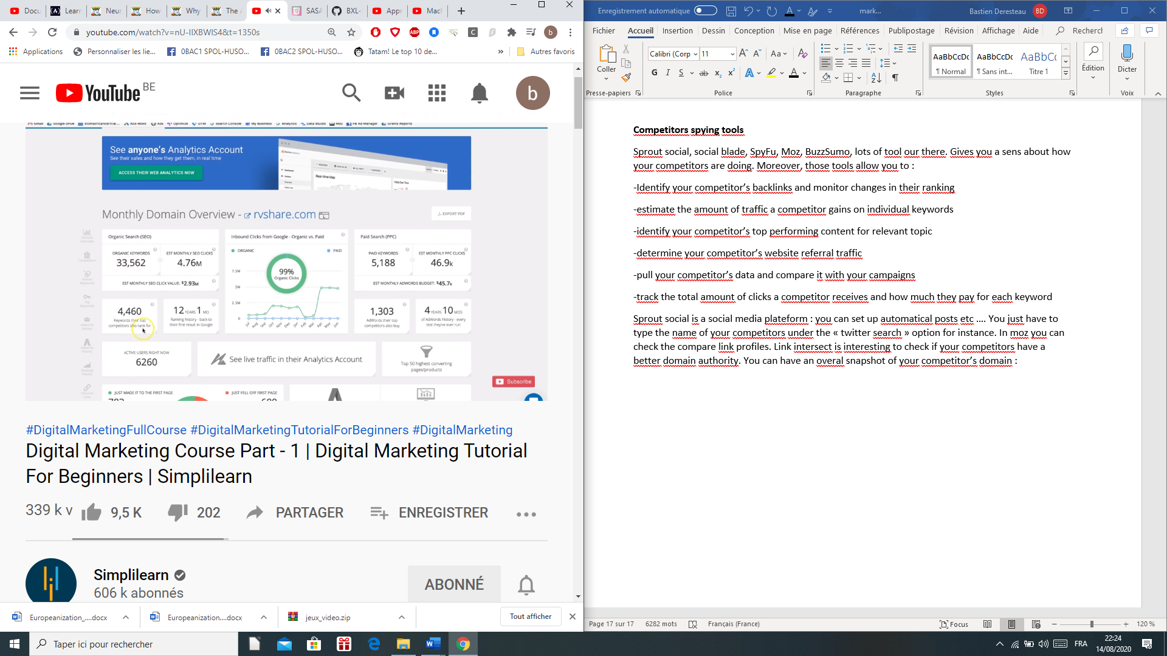

In Campains you have acess to action insights.

**What about paid marketing tools ?**

There are PPC ads, display advertisements or social media paid ads. Among PPC tools youll find google adWords editor, google AdWords keyword planner, bing ads editor, wordStream advisor. You can monitor which ad receives the most traffic, identify the most profitables keywords and monitor your advertisements across differents locations and devices and analyze competitor’s data. Paid tools are AdRoll , creto, celtra, wideOrbit, …. With those tools you can monitor whether you have chosen the right keywords and gained high customer engagement. Then you might reach the target audience with audience insights. After you can also improve your campaigns by monitoring. In paid social media ads marketing tool you have facebook ads manager, adEspresso, Qwaya, tweepi, …

Thusy ou might wabba review and relaunch your ad campaigns and measure conversion and gain inisghts about facebook user. You can also target people based on their activities such as purchase intent, device usage, travel preferences, …. Google ad sis realy a powerfull tool regarding all of this. You might work more efficiently in team thanks to that tool. You can even see how image ads are performing.

**What about social media marketing tool ?**

Tools : hootsuite, buffer, tweetDeck, sprout social. With the last one you can check precises informations about how your campaign or website is performing on the different social media plateforms. You can organize and schedule your posts. For instance you might wanna checks which were the post stalking about mail delivery.

**Search engine optimization**

When to use ? : when your competitors have better content than yours, when there is improper usage of keywords, when there are poor link building practices, when a webpage load time is slow or the website does not have a good UI also your website might be de indexed by mistake.

To sum up, SEO is the practice of increasing organig traffic on SERP : search engine result page. To what does SEO is paying attention ? there are several criterias such as : the content relevance, suitable titles, logical structure, suitable synopsis, content neat and readable ?

Ie, for google, it means that the website must have engaging and relevant content, suitable title tags and URL, header tags, meta description and responsive design + loading speed.

How do google rank websites ? it crawls it, index it and then rank it. Crawling : google has box and those box go to web server and crawl every findable pages by following their links. Basically, they scan the website and copy the entirer websites content and then stores it in search engines index. SEO is highly relevant since when a user types a query on google search engine, the most relevant website from the index will appear on the search result based on multiple factors like users location, language, user experience, …

There are two strategies :

One page SEO

is the process of optimizing elements on your website itself , elements are : keyword research, title tag, meta description, header tag, keyword usage, internal links and site maps.

You need to do keyword research , it is the **most important thing,**  how much traffic does come from that keyword ? Where the competition is for that keyword ? It is a practice where you choose the primary and secondary keywords around which meta tags and content will be bases on. The primary components to keyword research are : search volumes, relevancy and competition of course. How much volume does that particular keyword gets in x time of the year ? Best practice : put all your relevant keyword on a spread sheet and then check which one are the bests. Pick the keyword you wanna optimize for. If a keyword rates high, youll get more traffic to your website but also more competition so pay attention to the time when you are doing those type of actions.

Tittle tag : thats whats user see first so most important factor in SEOIt must be between 50 and 60 charactersotherwise google wont display all characters. Tittle tag also influence clicking rate. When tittle tag is optimized you want to update meta description as well with a brief description of up to 155 characters that summarizs the content of a webpage. They are displayed on the search engine page results. They can offer a longer and thus better understanding about what the page is offering. URL is also what people are seeing soi t is relevant to the keyword quey. Header tags are html tags that are structuring the webpage with h1 to h6 tags. H1 et H2 tags are important. Same goes for the <strong> and <em> tags. Internal linking must link to other relevant websites and youll have better SEO. Sitemap are a hierarchy list of a website that is designed to help both users and search enigines to understand the structure of a website, there are two types of them : HTML sitempas that are designed for humans and XML sitemaps that are designed for crawlers.

Off page SEO

Optimization is the process of linking or promoting your website using link building that helps in improving website recognition, credibility, trustworthiness and authority. IE : other website have to link to yours to assess its credibility. **Benefits of off page SEO might be an increase in traffic, high domain authority, better credibility, increase in page rank and increase in brand awareness.** For instance : how many links from wikipedia are pointing towards my webpage ? You might drive referral traffic and increase websites authority, also high quality content creation for strategoes of link building. Then achieve off site engagement through quora facebook twitter or by collaborating with bloggers. You might opt for getting backlinks from relevant site and use keywords in your titles and tags in order to rank high in search engines but do not duplicate title on multiple web pages and do not copy other websites content also avoid back links from irrelevant sites and finaly write engaging and latest content. Finally do keyword research and avoid keyword stuffing.

After, build internal links. Regarding URL structure, a url consists of a protocol, domain and subdirectories ( specific folders or subfolders). A well structured URL provides both users and search engines a clear information of what the web page is about. Know that short url are ranking better than long ones. The rest is about HTML tags such as alt or text tags, if they are well constructed, the website will rank better, know that you have to keep your alt text shorter than 125 characters. Add breadcrumbs to all your product pages.

Finally there is the **google tag manager** : you have to create an account, create a container, create a tag add tracking id, install preview and publish and in the end remove old codes. This tool allows you to fast testing and deployement of codes since all tags are managed in one place. It is a simple version control system with auto event tracking feature. You might also by pass the web master with that kind of tool. Gérez l'ensemble de vos balises sans modifier le code. Google Tag Manager est un outil gratuit et facile à intégrer qui vous permet de gérer les balises de façon simple et fiable. Avec Google Tag Manager, le processus incluant la réception, le test, le contrôle qualité et le déploiement d'une balise nous prend environ une heure. C'est vraiment beaucoup plus rapide.

Technologie d'insertion de balises

Maîtrisez parfaitement la définition et le déclenchement de vos balises.

* Compatibilité avec Accelerated Mobile Pages (AMP)

Simplifiez le déploiement de vos balises sur les sites AMP. Dans Tag Manager, les conteneurs AMP sont compatibles avec les plates-formes publicitaires de Google et les outils tiers. Examinez les [balises acceptées](https://support.google.com/tagmanager/answer/6106924?utm_source=marketingplatform.google.com&utm_medium=et&utm_campaign=marketingplatform.google.com%2Fabout%2Ftag-manager%2Ffeatures) et les informations sur les [variables intégrées](https://support.google.com/tagmanager/topic/7182737?utm_source=marketingplatform.google.com&utm_medium=et&utm_campaign=marketingplatform.google.com%2Fabout%2Ftag-manager%2Ffeatures).

* Chargement asynchrone des balises

Déclenchez des balises de façon asynchrone pour qu'elles se chargent indépendamment les unes des autres et ne ralentissent pas vos pages. Ces dernières peuvent ainsi se charger plus rapidement, et la collecte des données peut démarrer plus tôt.

* Définition de variables réutilisables

Sélectionnez les données les plus importantes sur vos pages et collectez-les facilement à l'aide de [variables](https://support.google.com/tagmanager/answer/6106899?hl=fr&ctx=cb&src=cb&cbid=1t61p0lar5hpb&utm_source=marketingplatform.google.com&utm_medium=et&utm_campaign=marketingplatform.google.com%2Fabout%2Ftag-manager%2Ffeatures).

* Compatibilité avec les applications mobiles

Grâce à la compatibilité avec [Firebase](https://firebase.google.com/?utm_source=marketingplatform.google.com&utm_medium=et&utm_campaign=marketingplatform.google.com%2Fabout%2Ftag-manager%2Ffeatures" \t "_blank), vous pouvez mettre à jour les statistiques marketing quand vous le souhaitez, et envoyer ces données à Google et d'autres partenaires, comme Kochava, Tune, AppsFlyer, Apsalar et Adjust.

* Mise en veille des balises

Vous pouvez désactiver provisoirement le déclenchement d'une balise sans la supprimer ni ajuster ses déclencheurs. Cette fonctionnalité est idéale pour résoudre un problème ou travailler sur une campagne limitée dans le temps.

* Liste noire de balises

Gardez le contrôle de la sécurité de votre site. Définissez des balises ou des types de balises spécifiques susceptibles d'être déclenchés à partir de vos pages.

* Séquençage des balises

Le [séquençage des balises](https://support.google.com/tagmanager/answer/6238868?utm_source=marketingplatform.google.com&utm_medium=et&utm_campaign=marketingplatform.google.com%2Fabout%2Ftag-manager%2Ffeatures) vous permet de spécifier les balises à déclencher immédiatement avant ou après une balise donnée, pour faire en sorte que les choses se passent exactement comme prévu.

Facilité d'utilisation

La solution Tag Manager s'adresse avant tout aux responsables marketing, mais elle est aussi très appréciée des équipes informatiques, en raison de sa conception conviviale et de sa sécurité.

Tout réduire

* Interface Web facile à utiliser

Privilégiez la simplicité. Tag Manager est conçu pour être intuitif et facile à utiliser.

* Dossiers

Organisez les balises, les déclencheurs et les variables sous forme de groupes logiques afin d'en faciliter la gestion pour vous et votre équipe.

* Recherche instantanée et saisie semi-automatique

Trouvez rapidement et facilement tout ce dont vous avez besoin dans vos conteneurs grâce aux fonctionnalités de recherche instantanée et de saisie semi-automatique.

* Publication ultra-rapide

Ajoutez ou modifiez des balises en quelques clics, puis publiez ces changements presque instantanément auprès des utilisateurs.

* Mode Aperçu

Découvrez l'impact réel des modifications apportées à votre site avant de les mettre en œuvre.

* Aperçu des balises du site

Visualisez l'ensemble des balises de votre conteneur (et les déclencheurs associés) d'un seul coup d'œil. Vous pouvez facilement ajouter des balises, ou sélectionner celles que vous souhaitez modifier ou supprimer.

* Historique des versions

Gardez une trace détaillée de tout ce qui a été publié sur votre site, et revenez facilement et à tout moment à une version précédente si vous le souhaitez.

* Espaces de travail

Travaillez facilement sur les balises au même moment que vos collègues. Créez simplement un espace de travail, effectuez des modifications et appuyez sur "Publier" sans que cela n'ait d'incidence sur les autres espaces de travail.  
  
Les entreprises qui utilisent Tag Manager 360 disposent d'un nombre illimité d'espaces de travail.

Comptes et rôles utilisateur

Partagez l'accès approprié avec toutes les personnes concernées. Contrôlez les autorisations pour faire en sorte que les responsables marketing et les développeurs puissent travailler ensemble en toute sécurité et efficacement.

Tout réduire

* Compatibilité multicompte

Les agences gérant plusieurs comptes pour différents clients peuvent afficher l'ensemble de leurs comptes au même endroit et basculer facilement de l'un à l'autre.

* Compatibilité multi-utilisateur

Vous pouvez facilement collaborer avec tous les membres de votre équipe, car le compte peut être utilisé par de nombreuses personnes.

* Autorisations au niveau utilisateur

Les [autorisations utilisateurs](https://support.google.com/tagmanager/answer/6107011?hl=fr&utm_source=marketingplatform.google.com&utm_medium=et&utm_campaign=marketingplatform.google.com%2Fabout%2Ftag-manager%2Ffeatures) vous permettent de sélectionner des niveaux d'accès pour différents utilisateurs. Par exemple, vous pouvez décider que les responsables marketing ont la possibilité d'effectuer des modifications, mais que seule l'équipe informatique peut les publier.

* Approbations (Tag Manager 360 uniquement)

Vous pouvez impliquer davantage de parties prenantes dans le processus d'ajout de balises, sans leur accorder de droits de publication complets.

* Zones (Tag Manager 360 uniquement)

Offrez aux utilisateurs la possibilité de publier certains types de balises dans des parties spécifiques de votre site. Par exemple, vous pouvez accorder des droits de publication à votre équipe marketing et vos agences pour leurs propres conteneurs, mais les limiter à vos pages marketing. Elles peuvent ainsi gérer l'insertion de leurs balises de façon indépendante, et cela permet de réduire les efforts que les administrateurs et les développeurs doivent fournir.

Déclencheurs

Déterminez où et comment vos balises se déclenchent afin d'obtenir toutes les données dont vous avez besoin.

Tout réduire

* Déclencheurs d'événements automatiques

Définissez les balises pour qu'elles se déclenchent lors de certains événements sur le site, sans code supplémentaire. Des [types de déclencheurs](https://support.google.com/tagmanager/answer/6106961?hl=fr&ref_topic=3441647&utm_source=marketingplatform.google.com&utm_medium=et&utm_campaign=marketingplatform.google.com%2Fabout%2Ftag-manager%2Ffeatures) automatiques sont désormais disponibles pour les [vidéos YouTube](https://support.google.com/tagmanager/answer/6106961?hl=fr&ref_topic=3441647&utm_source=marketingplatform.google.com&utm_medium=et&utm_campaign=marketingplatform.google.com%2Fabout%2Ftag-manager%2Ffeatures), la [profondeur de défilement](https://support.google.com/tagmanager/answer/6106961?hl=fr&ref_topic=3441647&utm_source=marketingplatform.google.com&utm_medium=et&utm_campaign=marketingplatform.google.com%2Fabout%2Ftag-manager%2Ffeatures) et la [visibilité des éléments](https://support.google.com/tagmanager/answer/6106961?hl=fr&ref_topic=3441647&utm_source=marketingplatform.google.com&utm_medium=et&utm_campaign=marketingplatform.google.com%2Fabout%2Ftag-manager%2Ffeatures).

* Clics

Définissez une balise pour qu'elle se déclenche lorsqu'un utilisateur clique sur un élément spécifique (par exemple, sur le bouton "Acheter maintenant" ou sur un lien qui le redirige en dehors de votre site).

* Événement personnalisé

Définissez le déclenchement d'une balise en fonction d'un événement enregistré personnalisé (par exemple, un utilisateur qui interagit avec un widget ou un lecteur vidéo personnalisé sur votre site).

* Envoi de formulaire

Définissez une balise pour qu'elle se déclenche lors de l'envoi d'un formulaire donné (aucun code supplémentaire n'est requis).

* Pages vues et historique des modifications

Définissez une balise pour qu'elle se déclenche lorsqu'une page spécifique s'affiche (par exemple, lorsque son URL correspond à votre page de remerciements ou lorsqu'elle est chargée de façon asynchrone).

Modèles

Adoptez rapidement de nouvelles solutions marketing dès que vous êtes prêt, à l'aide de modèles intégrés pour Google, et de balises de mesure et de marketing tierces.

Tout réduire

* Modèles de balise courants

Accédez à notre liste de [modèles de balises](https://support.google.com/tagmanager/answer/2574372?hl=fr&topic=2574304&ctx=topic&utm_source=marketingplatform.google.com&utm_medium=et&utm_campaign=marketingplatform.google.com%2Fabout%2Ftag-manager%2Ffeatures) intégrés provenant de [fournisseurs tiers](https://support.google.com/tagmanager/answer/6106924?utm_source=marketingplatform.google.com&utm_medium=et&utm_campaign=marketingplatform.google.com%2Fabout%2Ftag-manager%2Ffeatures), qui ne cesse de s'étoffer, et aux balises Google.  
  
Si votre entreprise fournit une technologie d'insertion de balises et que vous souhaitez inclure un modèle, veuillez nous contacter pour faire partie de nos [fournisseurs de balises](https://www.google.com/appserve/fb/forms/tagvendorprogram/?utm_source=marketingplatform.google.com&utm_medium=et&utm_campaign=marketingplatform.google.com%2Fabout%2Ftag-manager%2Ffeatures).

* Balises HTML personnalisées

Pour ajouter une [balise HTML ou JavaScript](https://support.google.com/tagmanager/answer/2574372?hl=fr&topic=2574304&ctx=topic&utm_source=marketingplatform.google.com&utm_medium=et&utm_campaign=marketingplatform.google.com%2Fabout%2Ftag-manager%2Ffeatures#CustomHTML) qui n'est pas encore incluse comme modèle de balise, sélectionnez le type "Balise HTML personnalisée".

* Balises d'images personnalisées

Pour ajouter une [balise d'image](https://support.google.com/tagmanager/answer/2574372?hl=fr&topic=2574304&ctx=topic&utm_source=marketingplatform.google.com&utm_medium=et&utm_campaign=marketingplatform.google.com%2Fabout%2Ftag-manager%2Ffeatures#CustomImage) qui n'est pas encore incluse comme modèle de balise, sélectionnez le type "Balise d'image personnalisée".

* JavaScript personnalisé

Les variables JavaScript personnalisées vous permettent de normaliser des valeurs ou de les afficher de manière conditionnelle à l'aide de JavaScript.

Intégrations

L'intégration de Tag Manager dans d'autres solutions Google vous permet de lancer et de gérer plus efficacement vos campagnes.

[Accéder au centre d'intégration](https://marketingplatform.google.com/home?openIntegrationCenter=true&utm_source=marketingplatform.google.com&utm_medium=et&utm_campaign=marketingplatform.google.com%2Fintl%2Ffr%2Fabout%2Ftag-manager%2Ffeatures%2F" \o "Accéder au centre d'intégration" \t "_blank)

Tout réduire

* Google Ads

Google Ads inclut des fonctionnalités complètes de suivi des conversions, de remarketing standard et de remarketing dynamique.

* Campaign Manager

Les responsables marketing et les agences peuvent transmettre directement les activités Floodlight à Tag Manager pour les faire valider, à partir de l'interface utilisateur Campaign Manager.

* Compatibilité avec des balises tierces

Les modèles de balises provenant de fournisseurs tiers simplifient la publication de code et permettent d'éviter les erreurs. Consultez les [modèles provenant de fournisseurs](https://support.google.com/tagmanager/answer/6106924?utm_source=marketingplatform.google.com&utm_medium=et&utm_campaign=marketingplatform.google.com%2Fabout%2Ftag-manager%2Ffeatures) déjà disponibles dans Tag Manager ou explorez ceux accessibles dans la [galerie de modèles de la communauté](https://tagmanager.google.com/gallery/#/?page=1).

Gestion automatisée des balises

Personnalisez votre infrastructure à l'aide de l'API multifonction de Tag Manager. Créez vos propres solutions et optimisez vos intégrations afin de les adapter à vos processus existants.

Tout réduire

* API

Intégrez simplement l'API Tag Manager dans vos systèmes afin de gérer facilement l'accès des utilisateurs, de prévisualiser et de publier des conteneurs et des balises, et bien plus encore.

* Intégration d'Apps Script

Google Apps Script vous permet d'accéder à l'API Tag Manager et de l'utiliser facilement. Automatisez et intégrez Tag Manager dans vos applications Google favorites, telles que Gmail, Agenda, Docs et Drive.

**Beginner's Guide to Social Media Marketing**

*It's never too late to embrace all of the free social media marketing platforms that are at your disposal.*



Image credit: d3sign | Getty Images

[](https://www.entrepreneur.com/author/torrey-tayenaka)

**[Torrey Tayenaka](https://www.entrepreneur.com/author/torrey-tayenaka" \o "Torrey Tayenaka: Article Author)**

ENTREPRENEUR LEADERSHIP NETWORK CONTRIBUTOR

*CEO of Sparkhouse*

[home](https://thesparkhouse.com/)

August 15, 2020 3 min read

Opinions expressed by *Entrepreneur* contributors are their own.

Starting a [social media marketing](https://www.entrepreneur.com/topic/social-media-marketing) plan can be intimidating. There’s [Facebook](https://www.entrepreneur.com/topic/facebook), [Instagram](https://www.entrepreneur.com/topic/instagram), [Linkedin](https://www.entrepreneur.com/topic/linkedin), [Tik Tok](https://www.entrepreneur.com/topic/tik-tok), [YouTube](https://www.entrepreneur.com/topic/youtube) and so many more. You need to make posts, make ads, comment on other’s posts, interact with your audience, grow your audience and stay authentic the entire time. It can be slightly overwhelming at first. Marketing on social media is only going to continue to grow, so it's important to keep some of the below tips in mind to expand your business and grow your brand.

**Know your product and your customers**

Do you know your product from your customer’s point of view? Answering some of these questions is a helpful way to determine your [marketing strategy](https://www.entrepreneur.com/topic/marketing-strategy). By figuring out the personality of your ideal customer, you’ll be able to make posts that appeal to them.

What do you sell? Why do you sell it? What are you most known for? What is your brand?

In a bio-persona of your ideal customer, what would they be like? Can you create multiple personas and go through the process of buying your product as this customer?

Using these personas, what words, images, or videos would appeal the most to them?

Using these personas, what would attract them to your social media? What would turn them away from your social media?

**Related:**[**7 Social Media Marketing Myths, Busted**](https://www.entrepreneur.com/article/353127)

**Understand each social media platform**

Whatever you post needs to be genuine and relevant to each social media platform. Is it a good piece of content for your current following? Is it a competition to get more followers and exposure? Is it a sponsored post to get traffic and conversions? How do your words and images relate to your end goal? Your words should be genuine, well-written, not too long (unless you’re a writer), and interesting. Relate to your audience. Tap into who they are and what they might want to hear.

**Remember:**

Good pictures, great words

Correct formats for all videos

**Related:**[**10 Laws of Social Media Marketing**](https://www.entrepreneur.com/slideshow/299334)

Be genuine and relatable. Make it personal and ask questions

Engage and interact – comment on other people’s posts, reply to comments left on your posts

**Get help if you need it**

You don’t have to go this alone. It’s a lot. That’s why there are experts out there to help. [Social media marketing agencies](https://next.entrepreneur.com/hire/social-media-experts/) can help with anything from your social media posts, to hiring writers, graphic designers, and videographers to produce high-quality, brand-relevant content. Starting out with an agency helps get things off the ground. You’ve already got a business to run, you can hand over the reins to someone who can lead your marketing.

Listening, focus, patience, quality, compounding, influence, value, the law of acknowledgment, reciprocity and accessibility/responsiveness.

**How to Manage Your LinkedIn Presence in 10 Minutes a Day**

*by* [**LUAN WISE**](https://www.socialmediaexaminer.com/author/luan-wise/) / AUGUST 11, 2020 / [**LEAVE A COMMENT**](https://www.socialmediaexaminer.com/how-to-manage-linkedin-presence-in-10-minutes-a-day/#disqus_thread)

[Share](https://www.facebook.com/share.php?u=https%3A%2F%2Fwww.socialmediaexaminer.com%2Fhow-to-manage-linkedin-presence-in-10-minutes-a-day%2F%3Futm_source%3Dfacebook%26utm_medium%3DSocial%26utm_campaign%3DSocialWarfare)

[Tweet](https://twitter.com/intent/tweet?text=How+to+Manage+Your+LinkedIn+Presence+in+10+Minutes+a+Day&url=https%3A%2F%2Fwww.socialmediaexaminer.com%2Fhow-to-manage-linkedin-presence-in-10-minutes-a-day%2F%3Futm_source%3Dtwitter%26utm_medium%3DSocial%26utm_campaign%3DSocialWarfare&via=luanwise)

[Share](https://www.linkedin.com/cws/share?url=https%3A%2F%2Fwww.socialmediaexaminer.com%2Fhow-to-manage-linkedin-presence-in-10-minutes-a-day%2F%3Futm_source%3Dlinkedin%26utm_medium%3DSocial%26utm_campaign%3DSocialWarfare)

[Email](mailto:?subject=How%20to%20Manage%20Your%20LinkedIn%20Presence%20in%2010%20Minutes%20a%20Day&body=Want%20a%20better%20return%20for%20the%20time%20you%20spend%20on%20LinkedIn%3F%20Looking%20for%20a%20LinkedIn%20engagement%20plan%20to%20follow%3F%20In%20this%20article%2C%20you%27ll%20find%20a%20plan%20for%20making%20the%20most%20of%20your%20time%20on%20LinkedIn%20to%20stay%20visible%2C%20build%20your%20network%2C%20nurture%20contacts%2C%20and%20find%20new%20opportunities.%20%231%3A%20Define%20Your%20End%20Goal%20for%20Using%20LinkedIn%20Having%20a%20plan%20before%20you%20dive%20into%20using%20any%20social%20media%20platform%20is%20the%20key%20to%20effective%20time%20management.%20If%20you%20don%27t%20know%20what%20you%27re%20looking%20to%20achieve%2C%20you%27re%20going%20to%20waste%20time%20and%20think%20that%20it%20doesn%27t%20work%20when%20you%20don%27t%20get%20any%20results.%0D%0A%0D%0ARead%20More%20Here:%20%20https%3A%2F%2Fwww.socialmediaexaminer.com%2Fhow-to-manage-linkedin-presence-in-10-minutes-a-day%2F%3Futm_source%3Demail%26utm_medium%3DSocial%26utm_campaign%3DSocialWarfare)

Pin

**743SHARES**

Want a better return for the time you spend on LinkedIn? Looking for a LinkedIn engagement plan to follow?

In this article, you’ll find a plan for making the most of your time on LinkedIn to stay visible, build your network, nurture contacts, and find new opportunities.

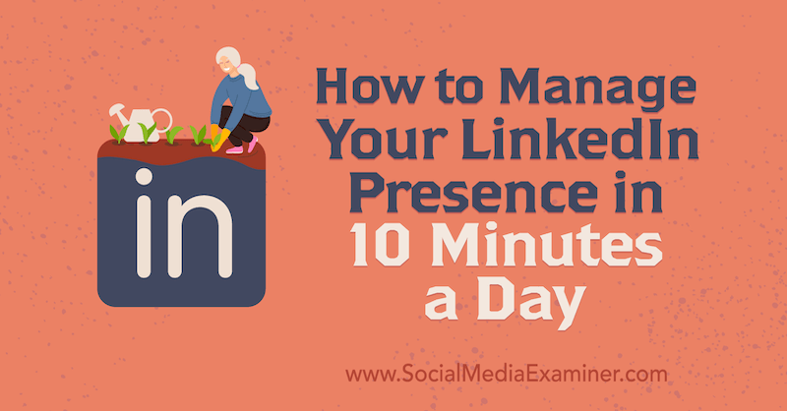

**#1: Define Your End Goal for Using LinkedIn**

Having a plan before you dive into using any social media platform is the key to effective time management. If you don’t know what you’re looking to achieve, you’re going to waste time and think that it doesn’t work when you don’t get any results.

Start by defining your objectives for using LinkedIn. Work out who you might find on this platform, what you want them to know about you and your business, and what information and insights you want to discover.

Traditionally seen as a tool for recruitment, LinkedIn presents many more opportunities and benefits to the business professional. You can

* Showcase your experience, skills, and career achievements.
* Create and maintain awareness of your brand.
* Promote content you’ve created or curated.
* Find new business opportunities.
* Find suppliers and partners.
* Gain referrals and recommendations.
* Drive traffic to your website.
* Identify and monitor the competition.
* Keep up to date with business news, trends, and opinion.
* Undertake market research.
* Learn new skills.

Once you know what you want to achieve, do some research to confirm that LinkedIn is the best platform to help you. If you’re looking to [develop new business](https://www.socialmediaexaminer.com/how-to-linkedin-turn-cold-prospects-warm-leads/), ask your existing customers if they’re active on LinkedIn (assuming that potential new customers will have similar usage patterns). If you want to find out what’s happening in your industry, search to find relevant companies and key contacts and check out how active they are on LinkedIn.

**Pro Tip**: If you find a LinkedIn profile that interests you, scroll to the Activity section. If there’s no Activity section, the profile is inactive—in other words, this person isn’t liking, commenting, sharing, or posting their own content. I suggest moving on from this profile because you’re unlikely to achieve much engagement and value from an inactive profile.

If the person has an Activity section on their bio, click on See All to view their articles, posts, and documents shared. You can see what content they’re engaging with on the All Activity tab and perhaps use this as a hook to start a meaningful conversation.

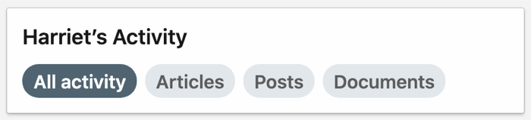

[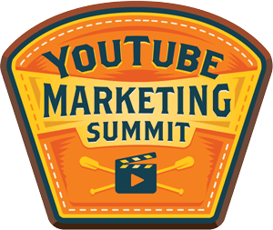](https://www.socialmediaexaminer.com/ytsummit/?smesite=yms20-site-midpage-ad-people-instructor)

Learn how to **improve your YouTube engagement and sales** with this new online training. Sale Ends Friday!

**MASTER YOUTUBE**LIVE THIS SEPTEMBER

[**LEARN MORE**](https://www.socialmediaexaminer.com/ytsummit/?smesite=yms20-site-midpage-ad-people-instructor)

**#2: Make Sure Your LinkedIn Profile Is Business-Ready**

Before you can consider using the LinkedIn platform properly, make sure you’re ready to do business. By that, I mean having your [LinkedIn profile](https://www.socialmediaexaminer.com/how-to-optimize-linkedin-profile-for-better-visibility/) set up and fully optimized to be informative and relevant to the audiences you want to speak to. Often, LinkedIn profiles are incomplete and a cut-and-paste of a CV or résumé.

A CV/résumé is a historical career document, which is perfect if you’re job seeking. It’s not so relevant if you’re in a current role with a business development objective. Potential customers don’t want to know that you’re the top salesperson and an accomplished new business hunter. They want to know how you and your business can help them so make sure your LinkedIn profile conveys that.

Getting found and then making the right first impression is the first step to achieving any objective with LinkedIn so ensure that your LinkedIn profile is All-Star strength and up to date with information relevant to your intended viewers.

A LinkedIn All-Star profile includes:

* A professional photograph (headshot)
* A headline
* An About section letting people know your career story and how you can help them now
* A populated Experience section with descriptions for each role
* A completed Skills section with a listing of up to 50 skills relevant to your job role, soft skills, and industry knowledge
* Education details

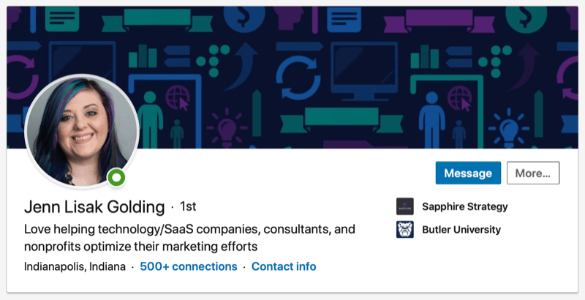

**#3: Prioritize Regularly Engaging on LinkedIn**

If you can log into LinkedIn daily, great. If it’s just once or twice a week, that’s just fine too.

LinkedIn is not as fast-moving as other social media platforms so you’re unlikely to miss too much if you’re not logged in 24/7. Plus, if your activity is focused, you’ll be able to head straight to what you need to achieve your objectives when you do log in.

A huge mistake many business professionals make—with both online and offline networking—is to be highly active when they’re not so busy and disappear into work as soon as a project appears. This yo-yo activity will make everything harder. Make using LinkedIn a regular habit and stay visible for when your network might need to use or refer details of you and your services.

**Pro Tip**: Look at your schedule and plan times you can use LinkedIn to achieve your objectives.

There’s no rulebook so make a commitment that works for you and your business. When you start to see results, you’ll want to spend more time on the platform. However, remember that consistency is the most important factor in building awareness and trust with your network.

**Check Messages, Notifications, and Latest News on LinkedIn**

There are a few priority tasks for LinkedIn, starting with your existing contacts. If you see a message notification on your desktop or mobile app, check it out and respond as required.

The notifications tab is the best place to see updates from your network that can help trigger conversations, whether it’s a “happy birthday,” congratulations on a new job, or comments on a post. Spotting ways to start meaningful conversations with contacts is the key to *social selling*, the process of developing relationships as part of the sales process.

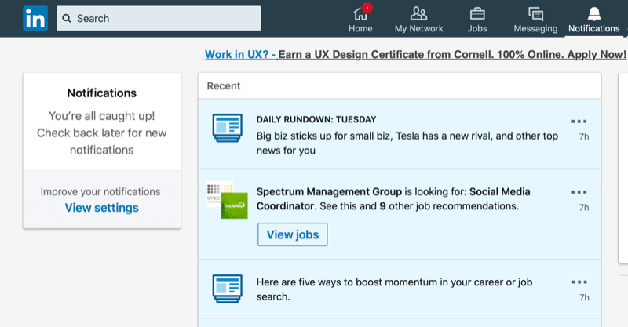

The Notifications tab is also where you can find the Daily Rundown news update. You might need to search “Daily Rundown” and follow the page to see it.

Viewing the top business headlines via the Daily Rundown and looking at “Today’s News and Views” on the desktop home page is hugely valuable. I check this daily to see if there’s relevant news I can share with my network and get involved in timely conversations with key contacts. It’s always good to show professional contacts that you’re up to date with what’s going on in the world.

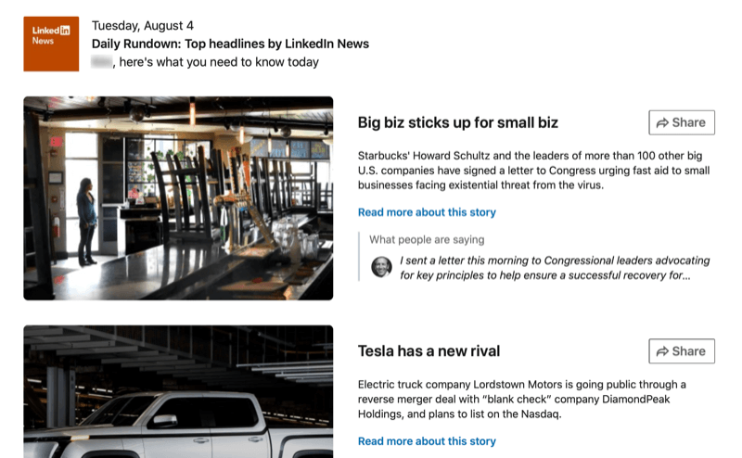

**Check the LinkedIn News Feed to Engage With Others’ Content**

Sharing content, whether it’s from your news feed or your own LinkedIn posts, is key to being visible in front of your connections. After checking messages and notifications, I head to the LinkedIn home page news feed to view content shared by my connections and the people and companies I follow.

The news feed is perfect for gathering information and insights from across my industry, and to find opportunities to stay visible in front of connections by reacting, commenting, and sharing their content with the rest of my network. I might do this publicly, or if I want the feedback to be more personalized, I’ll send a private message.

**Get YouTube Marketing Training - Online!**

[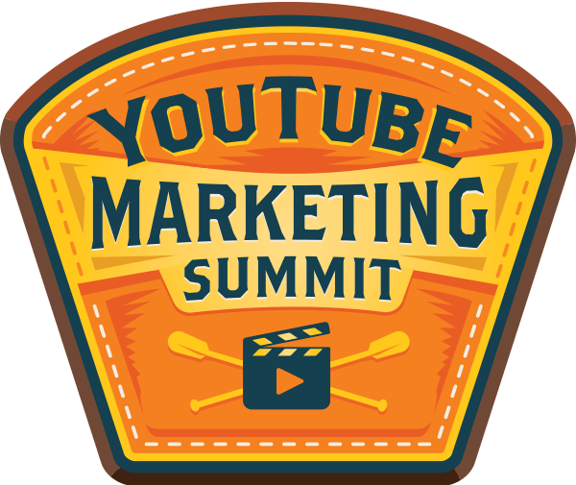](https://www.socialmediaexaminer.com/ytsummit/?smesite=yms20-site-midpage-text-ad)

Want to improve your engagement and sales with YouTube? Then join the largest and best gathering of YouTube marketing experts as they share their proven strategies. You’ll receive step-by-step live instruction focused on **YouTube strategy, video creation, and YouTube ads**. Become the YouTube marketing hero for your company and clients as you implement strategies that get proven results. This is a live online training event from your friends at Social Media Examiner.

04Days23Hours05Minutes42Seconds

[**CLICK HERE FOR DETAILS — SALE ENDS AUGUST 21ST!**](https://www.socialmediaexaminer.com/ytsummit/?smesite=yms20-site-midpage-text-ad)

**Pro Tip**: If you find your LinkedIn news feed is cluttered with content that’s not relevant and helpful for meeting your objectives, click on the three dots in the top right-hand corner of the post and click Unfollow. This means you’ll no longer see content from that connection. You’ll still be connected and that person will see your content but it will streamline your news feed so you can focus on information that’s most important to you and your business.

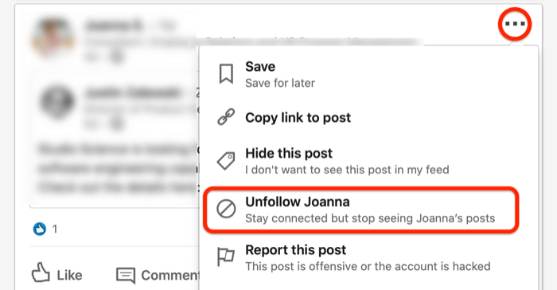

**#4: Share Your Content on LinkedIn**

The added benefit of [sharing your own content on LinkedIn](https://www.socialmediaexaminer.com/how-to-increase-linkedin-engagement-4-tips/) is the data that becomes available.

When you create your own posts, you’ll be able to see the number of views it receives in the feed. And when you click on the graph icon, you’ll see the companies that those viewers work for, their job titles, and locations. This is valuable insight into whether you’re achieving your objectives by reaching the right people with your content.

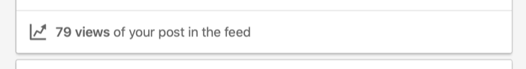

Some people will share content daily and others weekly or perhaps frequently. This is where it’s important to be consistent and have a content plan that works for you and your business. Post when you have something relevant and interesting for your audience. Don’t post just because you think you want to cross the task off your to-do list.

Here are some ideas for short updates you could post on LinkedIn:

* What’s happening behind the scenes of your business
* What you’re looking forward to such as an event you’re hosting or attending
* What you’re celebrating in your business such as a milestone, an award, or a new team member
* A top tip to share with your peers
* What you’ve read or watched (for example, a TED Talk) that’s inspired you
* What you’re supporting such as an awareness day or a community initiative

Don’t forget to encourage engagement by asking for feedback or comments at the end of your post. The more people react, comment, or share your content, the more visible you’ll be on LinkedIn. In turn, you’ll receive more profile views, which is another opportunity to start a conversation.

**#5: Identify New People to Connect With on LinkedIn**

[Building your network on LinkedIn](https://www.socialmediaexaminer.com/how-to-use-linkedin-to-build-powerful-network/) should be part of your regular activity. Whether it’s following up with people you’ve met (adding them to your LinkedIn network), searching for new people to connect with, or managing your invitations, this task is business-critical.

When you send connection requests, always personalize your invitation. Remind people how you’ve met or let them know why connecting with you is of interest. Think about what’s in it for them, not just what’s in it for you.

If you receive a connection request that doesn’t include a message, send a message to find out why they might want to connect with you.

To send a message, go to the My Network tab on a desktop device and click See All next to Invitations. On the next screen, you’ll see a blue Message link with each connection request. Click this link to send a message to that person.

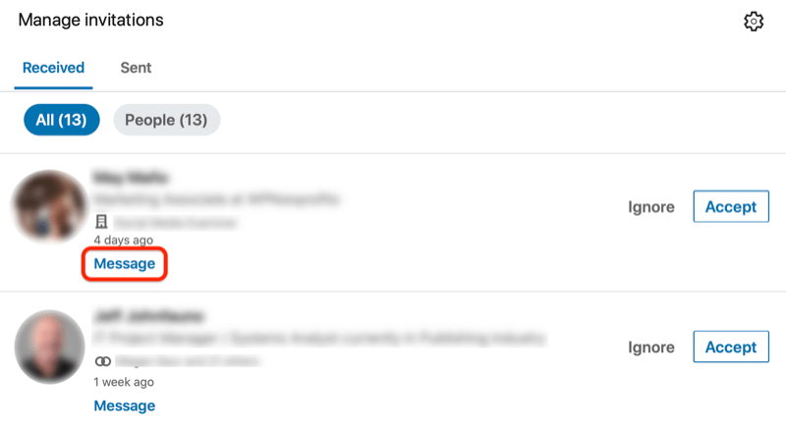

If you’re a premium LinkedIn user with full access to the details of people viewing your profile, you could also make this part of your weekly plan. View and send messages to build and nurture relationships.

For example, if it’s an existing 1st-degree connection, you could start your message like this:

*Hi <first name>*

*How are you?*

*I noticed you have taken a look at my LinkedIn profile this week, which prompted me to get back in touch!*

You could then refer to a previous conversation and try to arrange a next call or meeting to pursue any opportunities for doing business together.

If it’s a 2nd- or 3rd-degree connection and you haven’t been in contact before, you could send a message like this:

*Hi <first name>*

*I hope you’re having a good week.*

*I noticed that you have recently viewed my LinkedIn profile, and since we haven’t spoken before, I wanted to check to see if you found what you were looking for or if I can help at all?*

*Regards,*

*<name>*

**Join LinkedIn Groups**

[LinkedIn groups](https://www.socialmediaexaminer.com/5-steps-to-linkedin-group-success-how-to-create-and-manage-successful-group/) are last on the list for using LinkedIn because if you’re short on time, this isn’t a feature for you. However, if you’re getting results from LinkedIn and looking to network with peers or industry colleagues, you might find that LinkedIn groups are a good place to play. They do take some research to find the right ones and they require time and commitment to get results.

**#6: Measure Your Success on LinkedIn**

If you’re spending time on LinkedIn, you need to know that it’s time well spent. When you’re clear on your objectives, you can use your personal LinkedIn dashboard to measure your success. Check out this article on how to [analyze your LinkedIn profile using the LinkedIn dashboard](https://www.socialmediaexaminer.com/how-to-analyze-linkedin-profile-using-linkedin-dashboard/).

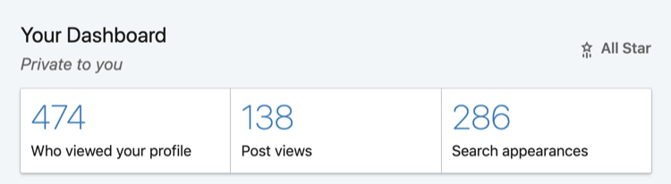

**Conclusion**

As a recap, here’s the weekly LinkedIn plan I follow to stay visible, build networks, nurture contacts, and find new opportunities. It takes approximately 10 minutes a day, with a longer batch of 30 minutes a week (sometimes I split this into two 15-minute sessions) and then additional time as required to write content for sharing.

**Daily:**

* Check the notifications tab and messages and respond as appropriate.
* Scroll through the news feed to gather insights from your connections and the companies and individuals you follow. Engage with content by reacting, commenting, and sharing as relevant to your business objectives.
* Check the Daily Rundown and News and Views for the latest business updates. Share or use the information as appropriate.

**Weekly:**

* Share content with your LinkedIn network. This might be from your company page, someone in your network, or your own content as a short-form update, longer article, or perhaps a [video](https://www.socialmediaexaminer.com/how-to-create-linkedin-videos-that-work/).
* Build your network by responding to invitation requests and sending invitation requests.
* Review your successes by analyzing your LinkedIn personal data dashboard and progress against set objectives.

**What do you think? Do you have a similar plan for managing your LinkedIn presence? Will these suggestions help you focus on your objectives and manage your time on LinkedIn?** Share your thoughts in the comments below.

**Instagram Live: Creative Hacks to Get Engaged Viewers**

*by* [**MICHAEL STELZNER**](https://www.socialmediaexaminer.com/author/mike-stelzner/) / AUGUST 14, 2020 / [**LEAVE A COMMENT**](https://www.socialmediaexaminer.com/instagram-live-creative-hacks-to-get-engaged-viewers-natasha-samuel/#disqus_thread)

[Share](https://www.facebook.com/share.php?u=https%3A%2F%2Fwww.socialmediaexaminer.com%2Finstagram-live-creative-hacks-to-get-engaged-viewers-natasha-samuel%2F%3Futm_source%3Dfacebook%26utm_medium%3DSocial%26utm_campaign%3DSocialWarfare)

[Tweet](https://twitter.com/intent/tweet?text=Instagram+Live%3A+Creative+Hacks+to+Get+Engaged+Viewers&url=https%3A%2F%2Fwww.socialmediaexaminer.com%2Finstagram-live-creative-hacks-to-get-engaged-viewers-natasha-samuel%2F%3Futm_source%3Dtwitter%26utm_medium%3DSocial%26utm_campaign%3DSocialWarfare&via=Mike_Stelzner)

[Share](https://www.linkedin.com/cws/share?url=https%3A%2F%2Fwww.socialmediaexaminer.com%2Finstagram-live-creative-hacks-to-get-engaged-viewers-natasha-samuel%2F%3Futm_source%3Dlinkedin%26utm_medium%3DSocial%26utm_campaign%3DSocialWarfare)

[Email](mailto:?subject=Instagram%20Live%3A%20Creative%20Hacks%20to%20Get%20Engaged%20Viewers&body=Do%20you%20want%20more%20Instagram%20engagement%3F%20Wondering%20how%20to%20grow%20and%20engage%20your%20Instagram%20Live%20audience%3F%20To%20explore%20how%20to%20get%20more%20engaged%20viewers%20on%20Instagram%20Live%2C%20I%20interview%20Natasha%20Samuel%20on%20the%20Social%20Media%20Marketing%20Podcast.%20Natasha%20is%20an%20Instagram%20expert%2C%20founder%20of%20Sol%20Studio%E2%80%94an%20Instagram%20creative%20studio%E2%80%94and%20host%20of%20the%20Shine%20Online%20Podcast.%20Her%20courses%20include%20Shine%20on%20Insta%20Stories%2C%20Mastering%20Instagram%2C%20and%20the%20IGTV%20Master%20Course.%20You%27ll%20learn%20how%20to%20use%20Instagram%20features%20to%20attract%20engaged%20viewers%20to%20your%20Instagram%20Live%20videos.%20You%27ll%20also%20discover%20how%20to%20improve%20the%20quality%20of%20your%20live%20video%20and%20how%20to%0D%0A%0D%0ARead%20More%20Here:%20%20https%3A%2F%2Fwww.socialmediaexaminer.com%2Finstagram-live-creative-hacks-to-get-engaged-viewers-natasha-samuel%2F%3Futm_source%3Demail%26utm_medium%3DSocial%26utm_campaign%3DSocialWarfare)

Pin

**644SHARES**

Do you want more Instagram engagement? Wondering how to grow and engage your Instagram Live audience?

To explore how to get more engaged viewers on Instagram Live, I interview Natasha Samuel on the [Social Media Marketing Podcast](https://www.socialmediaexaminer.com/shows/).

Natasha is an Instagram expert, founder of [Sol Studio](https://www.solstudiomarketing.com/)—an Instagram creative studio—and host of the Shine Online Podcast. Her courses include Shine on Insta Stories, Mastering Instagram, and the IGTV Master Course.

You’ll learn how to use Instagram features to attract engaged viewers to your Instagram Live videos. You’ll also discover how to improve the quality of your live video and how to save your Instagram live video for replay on IGTV.

**Listen to the Podcast Now**

This article is sourced from the [Social Media Marketing Podcast](https://itunes.apple.com/us/podcast/social-media-marketing-podcast/id549899114), a top marketing podcast. Listen or subscribe below.

**Where to subscribe**: [Apple Podcast](https://podcasts.apple.com/us/podcast/social-media-marketing-podcast/id549899114) | [Google Podcasts](https://www.google.com/podcasts?feed=aHR0cHM6Ly93d3cuc29jaWFsbWVkaWFleGFtaW5lci5jb20vZmVlZC9wb2RjYXN0Lw) | [Spotify](https://open.spotify.com/show/39jI0ihm8h0RVvNhxa8jgM) | [RSS](https://socialmediamarketing.libsyn.com/rss)

Scroll to the end of the article for links to important resources mentioned in this episode.

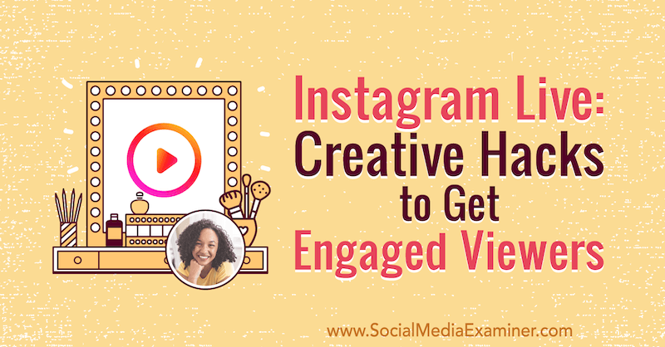

Natasha fell in love with writing, storytelling, and journalism while working on her high school newspaper. She pursued journalism in college but veered off into digital marketing and public relations, which is when she fell in love with social media and writing creative content for small businesses and brands.

In 2018, while still in her final semester of college, she started Sol Studio. She niched down to Instagram because she felt it was the place to be for all types of brands and businesses. On some social media platforms, only certain types of businesses can thrive but Natasha believes there’s a place for everyone on Instagram.

Today, Sol Studio manages content strategy on Instagram for product- and service-based businesses, coaches, and everything in between.

[](https://www.socialmediaexaminer.com/ytsummit/?smesite=yms20-site-midpage-ad-people-instructor)

Learn how to **improve your YouTube engagement and sales** with this new online training. Sale Ends Friday!

**MASTER YOUTUBE**LIVE THIS SEPTEMBER

[**LEARN MORE**](https://www.socialmediaexaminer.com/ytsummit/?smesite=yms20-site-midpage-ad-people-instructor)

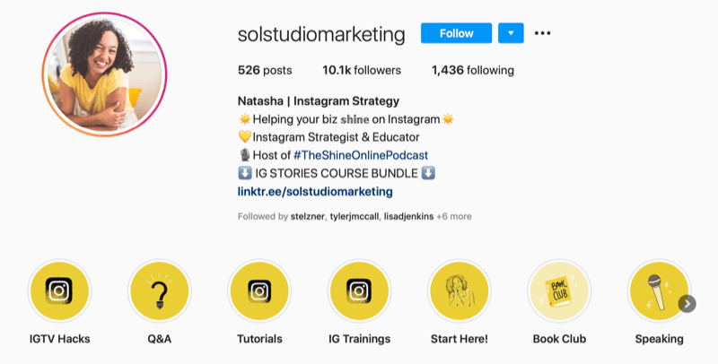

Natasha acknowledges that Instagram is very visual and that video is definitely at the forefront. That said, she sees content moving more toward longer-form captions, and that’s where she brings in the storytelling aspect she really enjoys.

**Why Marketers Should Use Instagram Live**

Viewers’ ability to like, comment on, ask questions, and request to join you live on-camera make Instagram Live a great platform to foster and grow community.

But Instagram Live’s value isn’t just related to engagement. Natasha’s suggestion to use Instagram Live video for business is based on her own success with it. She’s found that during enrollment periods, people often enroll in her courses right after she goes live.

Natasha believes that Instagram is focusing on live video content and notes that’s a good reason to make it part of your strategy. Another point in favor of live video is the ability to save it to IGTV for greater longevity.

Today, as the pandemic continues to shift the way many businesses operate, they’re turning to Instagram Live to host classes and stream online events.

Natasha knows that often people don’t go live because they feel like they need to make their videos perfect. But Natasha—and many others—love the more intimate, unpolished nature of live streams because going live feels more like having a one-on-one conversation with your followers.

**Creative Ways to Use Instagram Live for Business**

There are many creative ways you can use Instagram Live’s tools to generate a lot of engagement and serve your audience well. To visualize this, the Request to Join feature doesn’t just have to be used for interview-style live streams.

**Host a Live Themed Event to Build Community**

Natasha hosted a Christmas party and asked everyone to bring their holiday mugs and wear sweaters. When viewers joined her on-camera, they were able to ask her any question related to their businesses and Instagram marketing.

**Deliver Consulting**

Natasha recently did a live stream where she told her audience to use the question box to tell her about their business and what type of content they needed help with. She then brainstormed content together with them on the live stream and her audience found it really helpful.

**Run a Flash Sale During a Q&A**

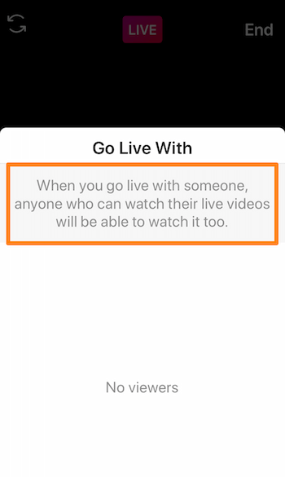Another example is to use Live to create urgency by running a sale on a product or service that lasts as long as the video lasts.

Natasha usually runs her Q&As for 20–30 minutes, which she feels is a perfect length for an IGTV replay or to [repurpose for a podcast](https://www.socialmediaexaminer.com/how-to-repurpose-audio-and-video-content-for-social-media-5-ways/). For training live streams, Natasha usually runs around 10 minutes.

**Go Live With a Partner to Increase Your Exposure**

[Going live with others](https://www.socialmediaexaminer.com/how-to-use-instagram-live-with-friends-for-business/) is a great growth hack. While people need to turn on your notifications to be notified when you post to Stories, IGTV videos, or other types of content, your followers are automatically notified when you go live. Notifications are also sent to the followers of anyone else you go live with. Not only do you get in front of your audience when you go live with someone else but also you get in front of their audience.

Natasha typically gains a few hundred followers after sharing a live stream with someone else.

**Instagram Live Performance Metrics**

Sometimes people will watch the whole live stream. But sometimes, they’ll tune in for as long as they can and then hop off because they have other things to do. This makes the analytics a little bit different from other types of video.

Instagram doesn’t tell you how long people watch your live, but at the end of your stream, it does tell you how many people in total tuned in.

When Natasha goes live, there might be 50 people viewing at a time, but over the course of the live stream, usually a few hundred people join.

**Promoting and Attracting an Audience to Your Instagram Live**

A basic tip for getting people to watch your live streams is to set a time and day that people can regularly expect you to go live. If, for instance, people know that you go live every Friday at 12PM, they’re more likely to tune into your live stream. Beyond that, the following tactics can greatly improve the chances you’ll have an engaged audience for your live stream.

**Build Pre-Broadcast Anticipation via Instagram Stories**

The best way to create excitement for your live stream is with Instagram Stories. Around 24–48 hours before you go live, post graphics and videos to share what you’re live will be about. It’s great to [add a countdown sticker to your story](https://www.socialmediaexaminer.com/how-to-use-instagram-countdown-sticker-business/) so people know when your live is happening and they can be notified when the countdown expires. Include a GIF or add an arrow pointing to the countdown sticker and explain that people can tap it to get reminders or share it.

**Take Audience Suggestions**

We often have our own ideas about what type of content our followers want to see and what they’d find most valuable but we’re not always right. [Use the poll sticker](https://www.socialmediaexaminer.com/instagram-stories-polls-how-to-use/) to give them the option to tell you and let them vote, and you may be surprised. On the day of the live stream, you can reveal the topic they picked and remind everyone to tune in to watch.

Letting your audience be a part of that process adds an interactive element to their engagement with you, and gives them an incentive to join you during the live stream. They’ll feel like they had a say in what you’re teaching, and you’re serving them the most popular topic so you’re more likely to get more eyes on your live stream.

**Amplify Your Live Using the Q&A Sticker**

You can use the questions sticker in a similar fashion—with an added bonus. If you go live right now, Instagram tells your followers that you’re live. But if you start [answering questions via the questions sticker on live streams](https://www.socialmediaexaminer.com/8-instagram-stories-hacks-to-give-you-creative-edge/), it’ll say you’re now doing a Q&A. It’ll change it to show what type of live you’re doing.

**Before You Go Live on Instagram: Tech and Tools Prep**

The priority for a quality live stream is good Wi-Fi; if your Wi-Fi is subpar, your live stream will be super-glitchy.

Next, make sure you eliminate the possibility of distractions and interruptions on your phone by switching to Wi-Fi and turning on Airplane Mode. Turn your notifications off and make sure you don’t get phone calls during your live stream because that can really mess it up. You’ll also want to be sure your phone is, and stays, charged.

Natasha highly recommends using something to hold your phone. When your hands are free, it’s easier to manage your live stream, pin a comment, move through slides, answer questions, and do other tasks. Natasha uses a phone stand that includes a charger so her phone is charging while she’s using it to go live.

**Workflow Tips for Successful Live Streams on Instagram**

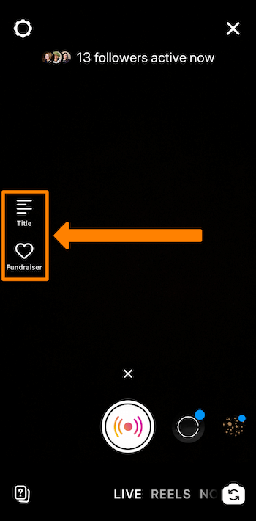Open up your Instagram stories and swipe all the way to the left for the live-streaming option. You’ll have the option to add your title, which is where you want to put the topic of your live stream. That’s also where you’ll have that fundraising option if you’ll be using your live stream to raise funds for non-profits.

**Setting Up and Opening a Live Stream**

Natasha likes to copy the title and pin it as a comment when she starts her live stream. That way, whether viewers see the title or the pinned comment when they tune in, the topic of her live is clear.

Because IGTV replay viewers won’t see that comment thread, Natasha uses the first minute of her live to tell people what she’ll be talking about. She also reminds her audience to put questions in the question box, let her know where they’re tuning in from, and generally gets people involved. She lets them know she’s present and ready to engage. After she summarizes what she’s talking about and what’s going on that day, she gets right into covering the topic.

**Get YouTube Marketing Training - Online!**

[](https://www.socialmediaexaminer.com/ytsummit/?smesite=yms20-site-midpage-text-ad)

Want to improve your engagement and sales with YouTube? Then join the largest and best gathering of YouTube marketing experts as they share their proven strategies. You’ll receive step-by-step live instruction focused on **YouTube strategy, video creation, and YouTube ads**. Become the YouTube marketing hero for your company and clients as you implement strategies that get proven results. This is a live online training event from your friends at Social Media Examiner.

04Days23Hours04Minutes32Seconds

[**CLICK HERE FOR DETAILS — SALE ENDS AUGUST 21ST!**](https://www.socialmediaexaminer.com/ytsummit/?smesite=yms20-site-midpage-text-ad)

**Bringing a Guest Into Your Instagram Live**

Because everyone has a different level of familiarity when it comes to live streams, Natasha created a mini-guide she sends to her scheduled guests so they know what to expect and how to join her live stream.

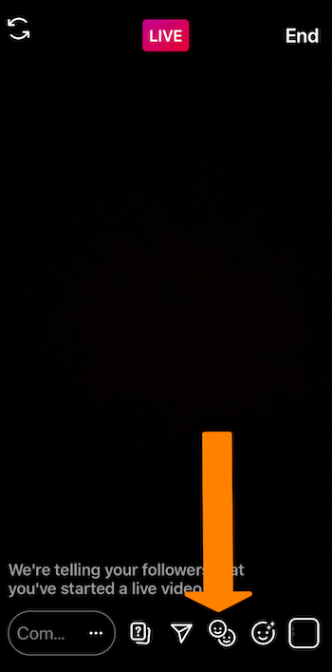There are two ways that people can join a live stream: You can invite a guest or someone watching your live can request to join by tapping the two smiley faces button at the bottom of the stream. When someone taps the button, you’ll see their request.

What does this look like in action? At the end of a live stream training about content pillars for Instagram, she said, “If anyone wants to request to join live, I’ll do pop-up coaching and we’ll walk through your pillars together so you can actually see an example.”

If you use this tactic, it’s important to let viewers know it’s a first-come, first-serve offer and give them some rules to govern what’s going on.

When Natasha extends this type of invitation, she tells her audience how to request to join her live and asks them to be prepared with certain information. Once people understand the structure of this type of interaction on live, you’re more likely to get quality people asking to join your live. People also tend to get really excited when they’re chosen, which is great for building your relationship with them.

**Taking Questions During Your Instagram Live**

When her stream has a lot of viewers, Natasha prompts people to ask questions via the [questions sticker](https://www.socialmediaexaminer.com/instagram-stories-stickers-marketing/) rather than in the comments. This allows her to see all of the questions in one place and helps her answer questions relevant to what she’s talking about.

When people are watching a live stream, they feel special if you mention them by name and reply to their question so Natasha makes a point to answer her viewers’ questions and really engage with them.

**How to Deliver a Presentation via Instagram Live**

Very few people know about the ability to present on Instagram Live but it’s available to everyone. While you’re live, tap on the little photo icon in the bottom-right corner of your phone. When you tap that photo icon, you can add any photos or video (think presentation assets) from your camera roll.

When you bring up a photo or video, your face shrinks to fit in the corner and your photo or video plays full-screen behind it. Then you simply tap through your assets in the same manner as you would go through a presentation deck. It’ll feel kind of like you’re doing a slideshow presentation. Note that if you share a video, audio of the video is muted.

**Creating Presentation Slides for Instagram Live**

To create slides, start with a 9:16 vertical video or photo. Make sure the background isn’t too light because all comments coming in from your audience (and the question response button) will be in white text. If you choose a white background, you won’t be able to see that engagement.

As you add text or bullet points to your slides, keep in mind that your camera window is going to be in the top-right corner of your screen so don’t put any necessary information up there.

The bottom left-hand side is where all of your comments are going to be so you want to avoid putting anything really important there either.

As you develop your slides, you can have a lot of fun creating templated graphics for yourself on Canva or your favorite graphic design tool. Natasha also has some templates available in her shop.

**Pro Tip**: Make sure you share your graphics to your phone as close as possible to when you go live so they’re the most recent graphics on your phone. That way, you won’t have to go scrolling and searching for them while you’re streaming.

**Saving Your Instagram Live to IGTV for Replay**

Before Natasha saves her live stream to IGTV, she preps a cover photo for the IGTV video because screen-grabs from the actual video often don’t look so great. She recommends designing a template for your cover photos so your replays have a similar look and feel. You should also write a description or caption for the IGTV video in advance so it’s ready to go.

You can add as many clickable URLs as you’d like to an IGTV caption. This is huge because if you mention a number of products or resources on your live stream, you can link to each one. Every IGTV video on Natasha’s channel has a clickable link, even if it’s just to her newsletter or a freebie, because it’s the only place you can add clickable links other than the one link in your bio (or the swipe-up in Stories if you have that feature).

With your cover and description assets prepped, you can set up your replay as soon as you’re off of the live stream.

You’ll also have the option to share the IGTV replay to your feed, which Natasha says you absolutely want to do because that’s where you’ll get the bulk of your views. Additionally, sharing the replay to your feed makes it more likely your followers will see it, along with others who might want to follow you and connect with your brand.

One important thing to note is that all of the engagement on your live stream will be wiped away from the IGTV replay. That means you’ll need to talk through things on the live stream to help people watching the replay understand what’s happening. To illustrate, if you’re responding to a question from the comments, read the question first because your replay viewers won’t see all of the likes, comments, and engagement that happened on the live stream.

**Key Takeaways From This Episode:**

* Find out more about Natasha on her [website](https://www.solstudiomarketing.com/" \t "_blank).
* Follow Natasha on [Instagram](https://www.instagram.com/solstudiomarketing/?hl=en).
* Listen to the [Shine Online Podcast](https://www.solstudiomarketing.com/podcast" \t "_blank).
* Check out [Natasha’s Instagram live-stream presentation templates](https://www.solstudiomarketing.com/sunshine-shop).
* See the [phone stand](https://www.amazon.com/dp/B07H86PVKB/) Natasha uses.
* Download the [Social Media Marketing Industry Report](https://www.socialmediaexaminer.com/report2020).
* Watch exclusive content and original videos from Social Media Examiner on [YouTube](https://www.youtube.com/socialmediaexaminer?sub_confirmation=1).
* Watch our weekly Social Media Marketing Talk Show on Fridays at 10 AM Pacific on [YouTube](https://www.youtube.com/socialmediaexaminer?sub_confirmation=1).

<https://www.theguardian.com/lifeandstyle/2020/aug/15/philip-n-howard-social-media-need-a-radical-rebuild>